Using alternative data sources to identify conservation areas at high-risk for ecological impact through increased recreation

# Summary

In Conservation Areas:

1. Recreation activities have ecological impacts; different activities have different impacts
2. People are recreating more during COVID-19; different activities increase in different areas
3. Baselines activity rates for *most* activities in *many* conservation areas are scarce or unavailable for comparisons

* Identifying areas where certain recreation activities have increased and may be ecologically impactful is not possible by conventional methods.
* Alterative data sources such as Google Trends may be useful in identifying areas where increased recreation may pose higher risk of causing ecological impacts.
* While this concept still requires testing and validation, these new data interact with an unprecedented time in human history by creating new opportunities to study human interactions with nature.

By: Zachary M. Moore, B.Sc., CERPIT, MNRM Candidate

# Introduction

Changes in human activity associated with the COVID-19 pandemic have changed the way humans interact with wildlife at a global scale. These changes have presented biologists with an unprecedented opportunity to study our interactions with the natural world 1–3.

These changes vary in effect from positive to negative. While many positive effects of reduced human mobility are being elucidated (see <https://www.c19-wild.org/> for ongoing projects), many negative effects such as increased poaching, and decreased interventions for species-at-risk or invasive species have also been described 2.

Some negative COVID-19-related **ecological impacts** may be associated with human **recreation** in **conservation areas** 4. While increases in human usage of urban greenspaces has been documented 5,6, human usage of non-urban ‘greenspaces’, conservation areas, may have increased as well, although has been less studied.

It is important to note that the positive impacts of physical activity, particularly those in urban greenspaces and conservation areas during and beyond COVID-19 are incredibly important for human well-being and attitudes toward conservation 7–9. Potential negative ecological impacts of increased recreation do not diminish the positive human welfare impacts but do highlight the need to better understanding of such impacts.

# Definitions

**Conservation Area:** here,any area of land managed with at least partial goals for the limiting of human development and the protection of biodiversity. Examples include national parks, provincial parks, crown land, and private conservation lands.

**Recreation:** here, refers to human activity in conservation areas for personal enjoyment. Examples include hiking, camping, mountain biking, all-terrain vehicle (ATV) trail riding.

**Jurisdiction:** here, refers to different regional areas as contained in the Google datasets discussed. Examples include “Canada” at the federal level, “Manitoba” at the provincial level, and “Division No. 11 – Winnipeg” at the municipal level.

**Ecological Impact:** here, refers to negative results of humans interacting with conservation areas. Examples involving recreation include soil compaction, vegetation loss, linear disturbances, invasive species, habitat fragmentation, wildlife avoidance, and noise pollution.

**Baseline:** here, refers to the regular human usage frequency for a given conservation area and recreation activity averaged across years or prior to a given visitor management strategy.

Hiking, mountain biking, and all-terrain vehicle use have been associated with usage dependent wildlife avoidance 4,10,11. Recreation activities can also result in soil compaction, vegetation loss, and other disturbances dependent on the usage amount and patterns throughout a given conservation area 4,11. To mitigate recreation-related ecological impacts, it is therefore important to understand how many people are normally using a conservation area, and in which activities they are participating. This knowledge would constitute a **baseline** understanding of recreation activities in any given conservation area.

Recreation usage baselines are notoriously scarce and difficult to establish 12. Some comprehensive usage data is collected in better-funded conservation areas in Canada such as national parks, but little to no data is available for areas with less funding such as provincial recreation areas, and even less for unmanaged conservation areas (i.e. crown land). These are areas with no baseline data, high amounts of human recreation, and possibly increased usage during COVID-19.

In this brief, advocation and evidence for the exploration of using alternative data sources to examine changes in human recreation within conservation areas is presented. By advancing this method, priority areas at high risk for increased ecological impact by recreation activities can likely be identified and incorporated into visitor management strategies to mitigate ecological impacts.

# Approach

There are multiple alternative data sources available to explore the ecological impacts of humans during COVID-19. Most documented and used have been community science platforms such as eBird ([www.ebird.org](http://www.ebird.org)) or iNaturalist ([www. iNaturalist.org](http://www.iNaturalist.org)), where everyday people input tens of thousands of wildlife observations from around the world 13. These have mostly been useful in urban environments, where concentrations of observations are highest 13. However, because these platforms require active participation, they present some logistical issues in their usage outside of heavily populated urban areas and present no information on recreation activities.

# Data Limitations

Google COVID-19 Community Mobility Reports:

1. Group data into ‘Parks’ which includes urban greenspaces, national parks, conservation areas, and many other areas, limiting examination of individual area types
2. Only provide 2020 data relative to January, limiting extrapolation or comparison to previous years
3. Are only useful in certain, more heavily populated areas (Table 1), and only present data from users with Google on their phones and ‘Location History’ settings turned ‘on’.

Google Trends Data:

1. Search interest in a term does not always equate to participation. It is assumed changes in search interest are proportional to changes in human behaviour.
2. Results vary by search term. For example, “camp” is not equivalent to “camping”.
3. Locational search interest does not account for mobility to other areas or use of Virtual Private Networks (VPN) disguising origin location.

An evolving approach that has been used to examine human recreation has been with Google ([www.google.com](http://www.google.com)) data 5,6. Because Google is so widely used and is constantly gathering new information from human movement and internet usage, it presents a wealth of untapped knowledge related to recreation and conservation areas.

Two Google data sources have been cited as useful in examining human recreation 5,6. The **Google COVID-19 Community Mobility Reports** ([www.google.com/ covid19/mobility/](http://www.google.com/%20covid19/mobility/)) are designed to provide public health workers with information regarding human movement patterns to assist with COVID-19 planning. It takes data from all phones with the ‘Location History’ setting ‘on’ and presents travel to various categorical location types as a percentage relative to the same day of the week in a pre-COVID week (the median of January 2020). Only data points with sufficient information to ensure anonymity of any individual person are presented. Data not considered to preserve anonymity are presented as blanks. In this way, increases of 100% represent a doubling in travel to a given category relative to January 2020. The categories include the broad term ‘Parks’, which includes urban greenspaces, national parks, provincial parks, and more. Analysis of this category in different **jurisdictions** can be used to elucidate where travel to ‘parks’ has increased in comparison to other areas 6.

The second Google data source previously used for examining recreation in response to COVID-19 is **Google Trends** ([www.google.com/trends](http://www.google.com/trends)). This source provides a platform to search the relative interest in any term searched through the Google search engine in any custom time period from the present dating back to 2004. This information is presented as a daily percentage relative to the most popular time in the period, which will always be 100%. By analyzing terms that are related to recreation activities or conservation area types, the relative interest in either can be determined at different points in time 5. This information can also be used at different jurisdictional scales to compare how interest in different recreation activities or conservation area types has changed through time in different places.

These two data sources present vast untapped potential to produce baselines of recreation activity in conservation areas by jurisdiction, albeit with several issues (see “Data Limitations”). Although both data sources require extensive validation against existing data for recreation and human usage in conservation areas, they can still be used preliminarily to examine the potential for informing managers on recreation activities. Such preliminary evidence for the usage of this data is presented here examining Canada at federal, provincial, and municipal jurisdictions.

# Preliminary Evidence in Canada

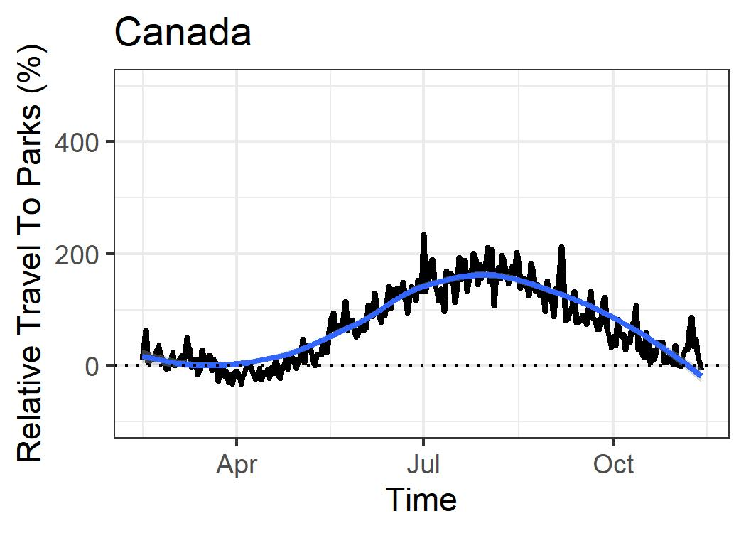

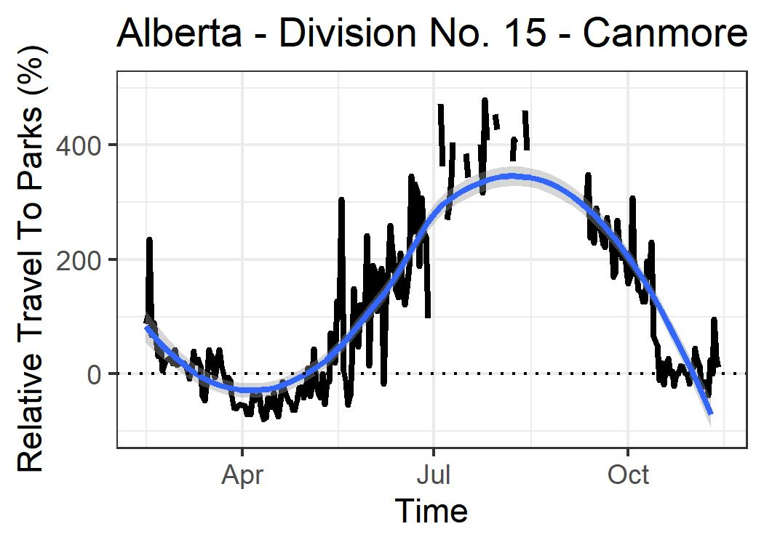

**Figure 1:** Google COVID-19 Community Mobility Report results for travel to ‘Parks’ averaged across all of Canada and in Canmore, Alberta. Travel is shown throughout 2020 as a percentage relative to January 2020. Blue lines show trends. In summer 2020, travel to parks increased by ~150% across Canada. In Canmore specifically, travel to parks increased by ~350%.

Examining the Google COVID-19 Community Mobility Reports provide some applications for relating changes in human recreation to conservation areas. In the summer of 2020, travel to ‘Parks’ across all of Canada increased by ~150% relative to January 2020 (Figure 1). This federal average can be used to identify jurisdictions at the provincial or municipal level that had higher or lower relative changes than the federal average. An example of such a place is Canmore, AB, which had a nearly 350% increase in travel to ‘Parks’ relative to January 2020. A logical inference of this result could be that the relative proximity of Canmore to several of the Rocky Mountain parks, such as Banff National Park, Jasper National Park, or Castle Provincial Park, results in increased travel to conservation areas compared with the rest of Canada. While this may seem an obvious observation, similar logic and comparisons can be used to examine jurisdictions with similar patterns and less obvious rationale.

Despite its application to some situations, use of the Google COVID-19 Community Mobility Report data is accompanied by several caveats. First, this data is only available for 2020, and so it cannot be determined if the increased travel to parks in Canmore compared to all of Canada is an annual phenomenon, or if it was uniquely the case in 2020. The anonymity restrictions associated with this data also limit the number of jurisdictions with ‘useful data’ due to the number of missing data points (Table 1). Finally, this data will be updated by Google only as long as it is helpful to Public Health workers during the pandemic. This source thus has some potential for examining recreation in conservation areas, but it is limited. If discussions were begun with Google to coopt this type of locational data in more useful formats for managers of conservation areas, it would have a vast potential for identifying human usage of conservation areas by type and location.

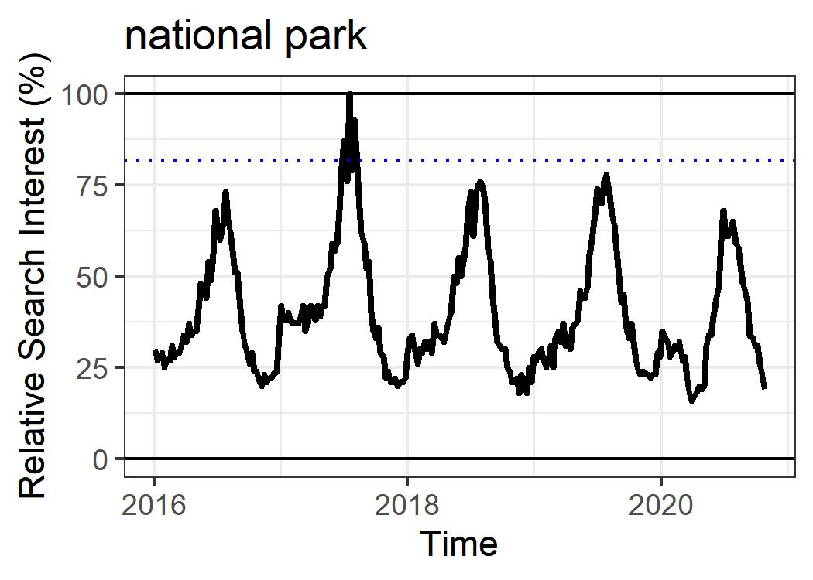

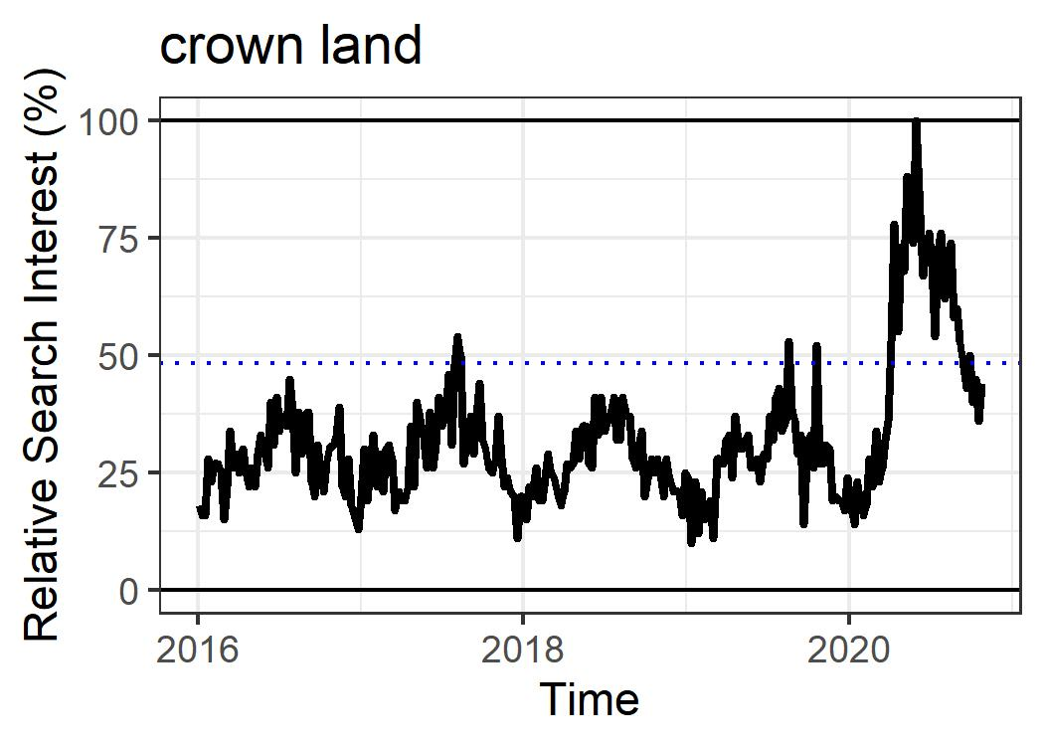

**Figure 2:** Google Trends results for searches for “national park” and “crown land” within Canada from 2016 to November 2020. Interest is shown as a percentage relative to the point in the 5-year period with the highest interest. Dotted blue lines show average annual maximum from 2016-2019. Both terms are annually cyclic, increasing in spring and decreasing in fall, but in 2020 “national park” decreased in interest by ~20% while “crown land” increased by ~50%.

**Table 1:** Google COVID-19 Community Mobility Report results by province. Subregions are geographically distinct areas by which data are separated and range from cities to districts. Because data points below a threshold size are omitted by Google to ensure anonymity, some regions do not contain discernible trends. Subregions with more than 50% of the data points present in 2020 are considered ‘useful’, and those with less than 50% are not. There was no useful data from the 3 Canadian Territories.

|  |  |  |  |  |
| --- | --- | --- | --- | --- |
| Province | # juris-dictions | # with  useful data | # without useful data | |
| Alberta | 18 | 8 | 10 |
| British Columbia | 26 | 10 | 16 |
| Manitoba | 16 | 1 | 15 |
| New Brunswick | 15 | 1 | 14 |
| Newfoundland and Labrador | 8 | 1 | 7 |
| Nova Scotia | 14 | 1 | 13 |
| Ontario | 51 | 16 | 35 |
| Prince Edward Island | 3 | 0 | 3 |
| Quebec | 94 | 14 | 80 |
| Saskatchewan | 18 | 2 | 16 |

Alternatively, Google Trends offers a much more immediate, robust, and versatile tool for examining recreation in conservation areas. For example, comparisons of the relative search interest in “National Park” and “Crown Land” over the last 5 years across Canada can be made (Figure 2). It is immediately evident that both terms have annual cycles whereby they increase in popularity in the spring and decrease again in the fall. This makes sense considering the seasonality of recreation in these types of conservation areas within Canada. However, other differences can be observed as well. For example, the highest interest in “National Park” over the last 5 years is observed in 2017, coinciding with the Canada 150 free entry promotion. “Crown Land”, alternatively, shows more shaky annual oscillations but then a massive spike in interest during 2020. This difference leads to the inference that, during COVID-19, interest in travelling to “Crown Land” has increased more than interest in traveling to “National Parks”. This is relevant considering recreation impacts are likely different between highly regulated national parks and unregulated crown land.

The Google Trends data additionally allows elucidation of interest in specific recreation activities. For example, interest in the terms “camping” and “mountain bike” in Canada both display annual oscillations with seasonality as when looking at the conservation area types (Figure 3). However, “camping” interest increased only minorly in 2020, whereas interest in “mountain bike” was nearly twice as high. This implies that, during COVID-19, interest in mountain biking increased much more than interest in camping. This is relevant to ecological impacts of recreation because mountain bikes have been found to have larger impacts on causing wildlife avoidance in high traffic areas 10, and because mountain biking can have more severe impacts on vegetation, trail degradation, and soil compaction if not managed properly 11.

**Table 2:** Google Trends search term results. 2020 Interest ‘increased’ if the max interest in 2020 was higher than the average max interest from 2016 to 2019.

|  |  |  |
| --- | --- | --- |
|  | Search Term | 2020 Interest |
| Activity | all-terrain vehicle | Increase |
|  | boat launch | Increase |
|  | camping | Small Increase |
|  | mountain bike | Increase |
|  | rock climbing | No Increase |
|  | trails | Increase |
| Area | conservation area | Increase |
|  | crown land | Increase |
|  | national park | No Increase |
|  | provincial park | Increase |

While these differences in interest do not equate precisely to activity, they are likely to be indicative of larger trends in recreation activities, specifically in response to COVID-19 (Table 2). Further exploring these and other relationships at the level of municipal jurisdictions and including terms for specific conservation areas or places may help conservation managers identify at which locations people are recreating more, and in which activities they are participating. With this information, managers can adjust visitor management strategies or enact new ones to ensure that humans enjoying these conservation areas does not lead to the reduction of their conservation value.

# Conclusions

# Recommendations

1. Use Google COVID-19 Community Mobility Reports only in areas with useful data to identify high increases in travel to parks.
2. Establish a standard list of search terms related to recreation activities. Use Google Trends to examine long and short-term trends, including recent changes in interest related to COVID-19.
3. When possible, validate interpretations of these results with existing recreation usage data (i.e. from tracked visitation and usage data for conservation areas).
4. Use this information to inform visitor management strategies and related management efforts.
5. Open dialogue with Google to determine if usage of locational data relevant for conservation management is possible.

Recreation in conservation areas has ecological impacts with varying severities depending on the amount of usage and the activities. A lack of baseline data regarding where and how people are recreating stifles the ability of conservation managers to produce strategies that effectively mitigate human visitation. By using alternative data sources, such as those from Google, managers can begin to examine these issues at municipal scales. Upon examination this data in Canada, it is clear that during the COVID-19 pandemic, some areas have had increases in parks visitation greater than the national average, and that certain recreation activities and conservation types have received greater interest than others. Further refining the usage of this analysis method could greatly impact conservation management and provide insight into recreation habits that previously would have been impossible.

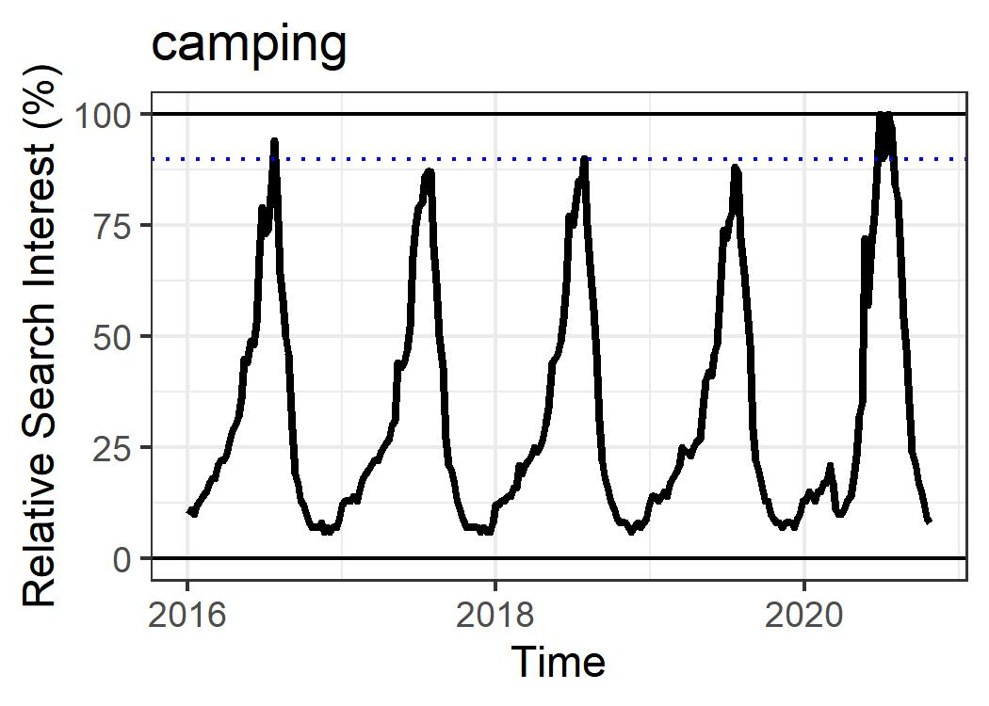

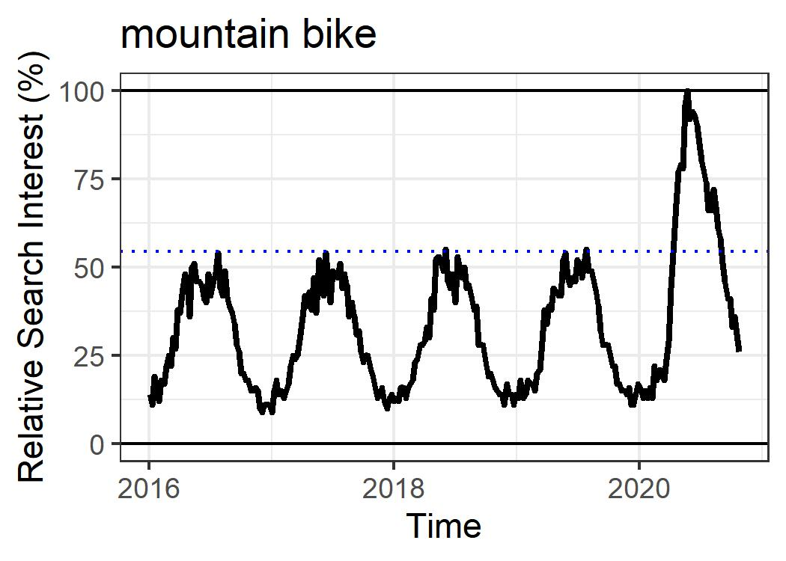

**Figure 3:** Google Trends results for searches for “camping” and “mountain bike” within Canada from 2016 to November 2020. Interest is shown as a percentage relative to the point in the 5-year period with the highest interest. Dotted blue lines show average annual maximum from 2016-2019. Both terms are annually cyclic, increasing in spring and decreasing in fall, but in 2020 “camping” increased in interest by ~10% while “mountain bike” increased by ~50%.

# References

1. Bates, A. E., Primack, R. B., Moraga, P. & Duarte, C. M. COVID-19 pandemic and associated lockdown as a “Global Human Confinement Experiment” to investigate biodiversity conservation. *Biol. Conserv.* 248, 108665 (2020).

2. Manenti, R. *et al.* The good, the bad and the ugly of COVID-19 lockdown effects on wildlife conservation: Insights from the first European locked down country. *Biol. Conserv.* 249, 108728 (2020).

3. Rutz, C. *et al.* COVID-19 lockdown allows researchers to quantify the effects of human activity on wildlife. *Nat. Ecol. Evol.* 4, 1156–1159 (2020).

4. Monz, C. A., Pickering, C. M. & Hadwen, W. L. Recent advances in recreation ecology and the implications of different relationships between recreation use and ecological impacts. *Front. Ecol. Environ.* 11, 441–446 (2013).

5. Kleinschroth, F. & Kowarik, I. COVID-19 crisis demonstrates the urgent need for urban greenspaces. *Front. Ecol. Environ.* 18, 318–319 (2020).

6. Burtscher, J., Burtscher, M. & Millet, G. P. (Indoor) isolation, stress, and physical inactivity: Vicious circles accelerated by COVID‐19? *Scand. J. Med. Sci. Sports* 30, 1544–1545 (2020).

7. Burtscher, J., Burtscher, M. & Millet, G. P. Jumping at the opportunity: Promoting physical activity after COVID-19. *Scand. J. Med. Sci. Sports* 30, 1549–1550 (2020).

8. Dwyer, M. J., Pasini, M., Dominicis, S. D. & Righi, E. Physical activity: Benefits and challenges during the COVID-19 pandemic. *Scand. J. Med. Sci. Sports* 30, 1291–1294 (2020).

9. Zhang, W., Goodale, E. & Chen, J. How contact with nature affects children’s biophilia, biophobia and conservation attitude in China. *Biol. Conserv.* 177, 109–116 (2014).

10. Naidoo, R. & Burton, A. C. Relative effects of recreational activities on a temperate terrestrial wildlife assemblage. *Conserv. Sci. Pract.* 2, e271 (2020).

11. Pickering, C. M., Hill, W., Newsome, D. & Leung, Y.-F. Comparing hiking, mountain biking and horse riding impacts on vegetation and soils in Australia and the United States of America. *J. Environ. Manage.* 91, 551–562 (2010).

12. Cole, D. N. & Wright, V. *Wilderness visitors and recreation impacts: baseline data available for twentieth century conditions*. RMRS-GTR-117 https://www.fs.usda.gov/treesearch/pubs/5592 (2003) doi:10.2737/RMRS-GTR-117.

13. Zellmer, A. J. *et al.* What can we learn from wildlife sightings during the COVID-19 global shutdown? *Ecosphere* 11, e03215 (2020).